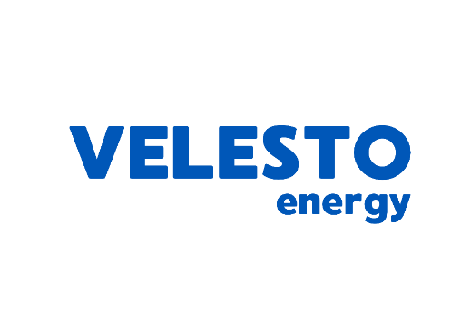

**Vendor Declaration Form**

Our company, ***<COMPANY NAME>***  (hereinafter referred as the “**Vendor**” which includes its directors, officers and employees) bearing registration number ***<COMPANY REGISTRATION NUMBER>*** who intends to conduct Business Transaction(s)* with Velesto Energy Berhad and/or its subsidiaries (“**Velesto Group**”) hereby:

1. **VENDOR INTEGRITY PLEDGE (“VIP”)**

**1.1 PLEDGES AND UNDERTAKES THAT:**

1. We have read and understood and comply with all applicable laws, rules, orders, decrees and regulations relating to anti-bribery, fraud, corruption and anti-money laundering (collectively “**the Applicable Laws**”).
2. We will ensure that our subsidiaries, affiliates including contractors, subcontractors, agents, advisors and consultants or otherwise (“**other Appointed Party**”) that we appoint to conduct Business Transaction(s) with Velesto Group also comply with the Applicable Laws.
3. We, including other Appointed Party, have not been convicted nor are we (including other Appointed Party) the subject of any investigation, inquiry or enforcement proceedings by the relevant authorities of any actual or suspected breach to the Applicable Laws and will report any actual or suspected breach to the Applicable Laws as soon as reasonably practicably and to the extent permitted by law, to Velesto Group.
4. We declare that we and our personnel shall exercise reasonable care and due diligence to avoid any situations of potential and/or actual conflict of interests.
5. We shall promptly inform Velesto Group in writing of a situation of actual and/or potential conflict of interest.

**1.2 AGREES THAT:**

1. In the event that we (including other Appointed Party) are in breach of any of the above, Velesto Group may immediately revoke the contract award, or terminate the contract for the Business Transaction(s) without any liability whatsoever on the part of Velesto Group to the Vendor. This is without prejudice to any other rights or remedies that Velesto Group may have or any other appropriate action which Velesto Group may seek under the terms of the applicable tender/ contract or Applicable Laws.
2. Should any person attempt to solicit any bribe or advantage (whether financial or otherwise) from the Vendor or any other person connected to the Vendor either as an inducement or incentive to be selected or as a reward, gift or bonus for being selected in the Business Transaction(s), or where the Vendor has reasonable grounds to suspect any breach of the obligations in this VIP, the Vendor will report such act to Velesto Group as soon as reasonably practicable.
3. **CONFLICT OF INTEREST (“COI”)**

We/I, on behalf of our/my company/corporation/partnership/sole proprietor (individually or collectively referred as “Vendor”) declare that as a Vendor and/or its directors and/or shareholders including related companies within our Vendor group of companies have no conflict of interest or potential conflict of interest including interest in competing business with companies in Velesto Group.

As a Vendor, We and/or I am aware that we have to declare to the Velesto Group that if any dealings, transactions, entry into contract with any company within Velesto Group which may give rise to a conflict as a Vendor, that we must declare the fact and nature, character and extent of the conflict to the Velesto Group, in particular, the contract representative of Velesto at Supply Chain Department.

Note: Conflict of Interest (“COI”) refers to situations where:

1. The interest of the Vendor and its group, interfere, or appear to interfere, with the interests of the Velesto Group; or
2. The Vendor and its group has conflicting interests that may make it difficult to perform its obligations any dealings, transactions or contracts.

The interest in a COI involving the Vendor and its group is not limited to direct financial interest but also include an indirect financial interest, non-financial interest (e.g. arising from relationships of directors/shareholders of its group), or competing loyalties or interests.

A potential COI is a COI that has yet to materialise or happen, but may arise subsequently due to, among others, prevailing relationships or interests of the Vendor and its group.

**\**Business Transaction(s) is(are) defined as Tenders, Quotations, Contracts, Letter of Awards and Purchase Orders.***

For and on behalf of the Vendor, Witnessed by,

………………………………………… ……………………………………

Name : Name :

Position : Position :

Date : Date :